**Chatbots for Fintech**

15 minutes read

### 

# Introduction

## What is a Chatbot?

Chatbots are artificial intelligence (AI) that simulates natural human conversations with their users. Many companies nowadays are finding success employing chatbots to automate conversations and assist customers, in lieu of an actual live human agent. Chatbot applications streamline interactions between users and services, enhancing customer experience and reducing the typical cost of customer service.

Users typically interact with them through messaging platforms like online website popups or virtual assistants. These chatbots see various uses, such as improving and scaling customer service, automating request routing, or efficiently gathering information. For example, rather than a boring and static FAQ page, a chatbot that answers your questions can provide better engagement. Chatbots can also be used to fill up forms, conduct surveys, or carry out interviews in an engaging manner. The possibilities are only limited by our imagination.



*Ask Jamie, an FAQ chatbot for Singapore’s NSmen.*

# Types of Chatbots

## Rule-based chatbots

As the name suggests, these chatbots use a series of predefined rules to communicate and act. Users get a set of options that lead the bot to their desired answers.

These bots are great when it comes to automating certain tasks. Those tasks include: booking a movie ticket, inquiring about flight timing, routing to a relevant service, and many more. Most companies also use rule-based chatbots to increase customer satisfaction and answer queries.

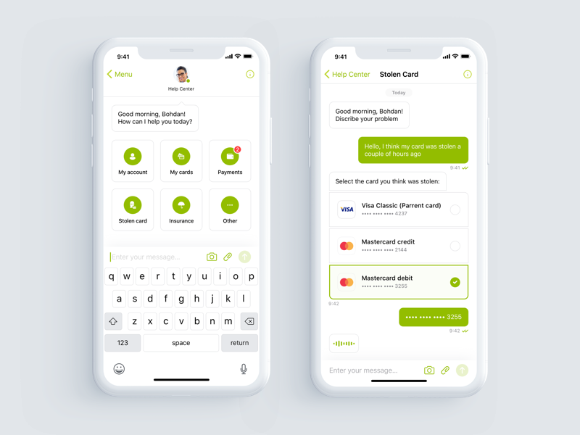

*Example of Rule-based Chatbot*

## AI- powered Chatbots

These bots use Machine Learning (ML) and Natural Language Processing (NLP) to understand people and learn from user inputs and requests.

Unlike typical rule-based chatbots that provide an array of options for selection, users can interact freely with AI chatbots as they are trained to understand free language and reply to them. These chatbots aim to make the interaction between computers and humans feel like communication between two people. They can remember the context of the conversation and the user’s preferences and can jump from one point of conversation to another. With time, they train themselves to understand more and more questions.

## What is NLP?

There are two parts to Natural Language Processing (NLP):

Natural Language Understanding (NLU) and Natural Language Generation (NLG).

The main steps in the NLU mechanism are:

* Tokenization – splitting a sentence into different parts, words, or “tokens”
* Part-of-speech tagging – determines which words are nouns, verbs, adjectives, etc.
* Stemming/Lemmatization – shortening a word to its basic form.
* Named entity recognition – finds entities in the text that the user has typed.
* Sentiment Analysis – the ability of the computer to recognise users' emotions and moods.

In a nutshell, suppose a user writes to an AI chatbot “What is the weather in Singapore today?”. The chatbot breaks down this sentence into Intents and Entities. An intent is an action or a request the user wants to perform or information he wants to get. An entity is a detail that compliments the Intent. It can be a location, date, color, size, flavor, etc. Using the above sentence example, the Intent in it would be “*Weather*”. The entities would be “*Singapore*” and “*today*”.

Once the chatbot understands what the user is requesting, it must generate, through NLG, the most appropriate response. An answer may be in the form of:

* a generic and predefined text;
* a text retrieved from a knowledge base that contains different answers;
* a contextualized piece of information based on data the user has provided;
* data stored in enterprise systems;
* the result of an action that the chatbot performed by interacting with one or more backend applications; or,
* a disambiguating question that helps the chatbot to correctly understand the user’s request

# What are Fintech Chatbots?

Fintech chatbots have become a smart solution for banks and the fintech sector to quickly start reaping benefits. Similarly to traditional chatbots, they are available 24/7, and are able to hold conversations via text or buttons, in lieu of providing direct contact with a live human agent. Given that 54% of people do their banking in the evening or during the weekends, this makes chatbots and their always-on working capacity even more attractive. Furthermore, resetting a password, managing transactions, or even opening up a line of credit is simple and seamless. Fintech chatbots can also handle multiple requests at a time, which makes them a hard-working part of any fintech institution.

## Chatbots in Fintech

AI is playing an increasingly crucial role in the financial and fintech services industry to keep with the expectations through chatbots as well. Talking fintech and finance with a robot is about as complicated as it sounds — unlike the basic live chat experience you might find on a retail website, a good fintech chatbot requires advanced artificial intelligence and machine learning technology for both conversation (natural language processing) and meaningful financial analysis, something which traditional chatbots lack.

Driven by these requirements, chatbots in banking have made incredible progress over the last five years, with the best solutions sending personalized, near-lifelike messages which make scripted, rules-based responses like Jamie look silly.

## Success Stories of Chatbots in Fintech

One example of chatbot success in fintech is chatbot Neo, which has been used by at least 2.5 million customers, CaixaBank saw a 20% reduction in calls to their contact center. Neo has had more than 23 million conversations and customers received fitting answers on 85% of their questions, needing no further (human) assistance.

Another example of chatbot success in fintech can be found at Bank of America, where some ten million users corresponded with chatbot Erica. Erica has helped more than 100 million client requests since its launch and knows the answer to more than 400,000 different financial questions.

## How are they different from traditional use cases?

When it comes to chatbots, the issue is that many people still think of them in terms of their early failures. They recall the text-only, frustrating experiences chatbots once provided. But chatbots have evolved way beyond their disappointing predecessors. They've progressed so much that we now call them conversational apps or conversational interfaces.

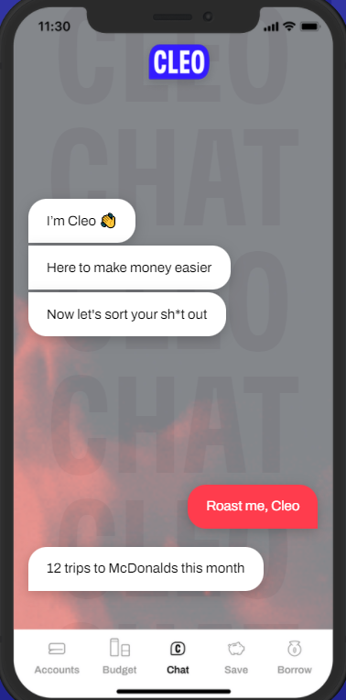 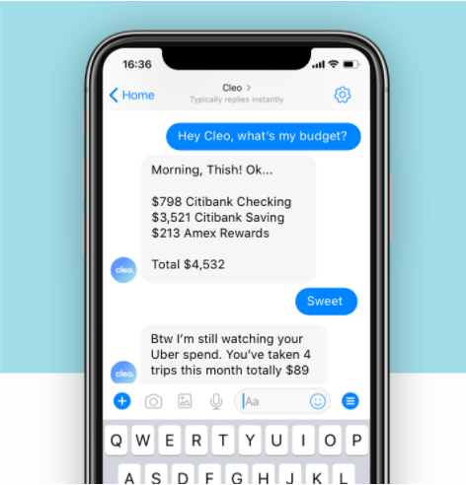

*Example of Chatbot Cleo*

Here is an example of a fintech chatbot, Cleo. Cleo's notion is aimed squarely at millenials and other heavily online users: a chatbot that is not only helpful but also has a snappy personality to fit current internet culture. It's a lighthearted take on fintech, which has a reputation for being stuffy and old-school. If you ask Cleo if tonight's Mcdonalds order fits within your budget, she'll likely react with a numerical answer as well as a witty quip about your spending patterns aimed to keep you on track with your financial objectives. She's a wonderful example of current chatbot technology that manages to feel realistic, competent, and humorous instead of throwing out fragmentary FAQ replies.

**1. Fintech chatbots are visually engaging**

Graphic components, text-based chat, and complex experiences are intertwined to make conversational applications. Conversational applications, rather than relying exclusively on text conversations, make use of buttons, graphics, embedded calendars, and other features to make things simpler. For all of our visual learners, here's an example: The time it takes to resolve a problem is cut in half because of its user-friendly design. Conversational applications cut the time it takes a consumer to achieve a goal in half and boost the number of objectives fulfilled by a quarter.

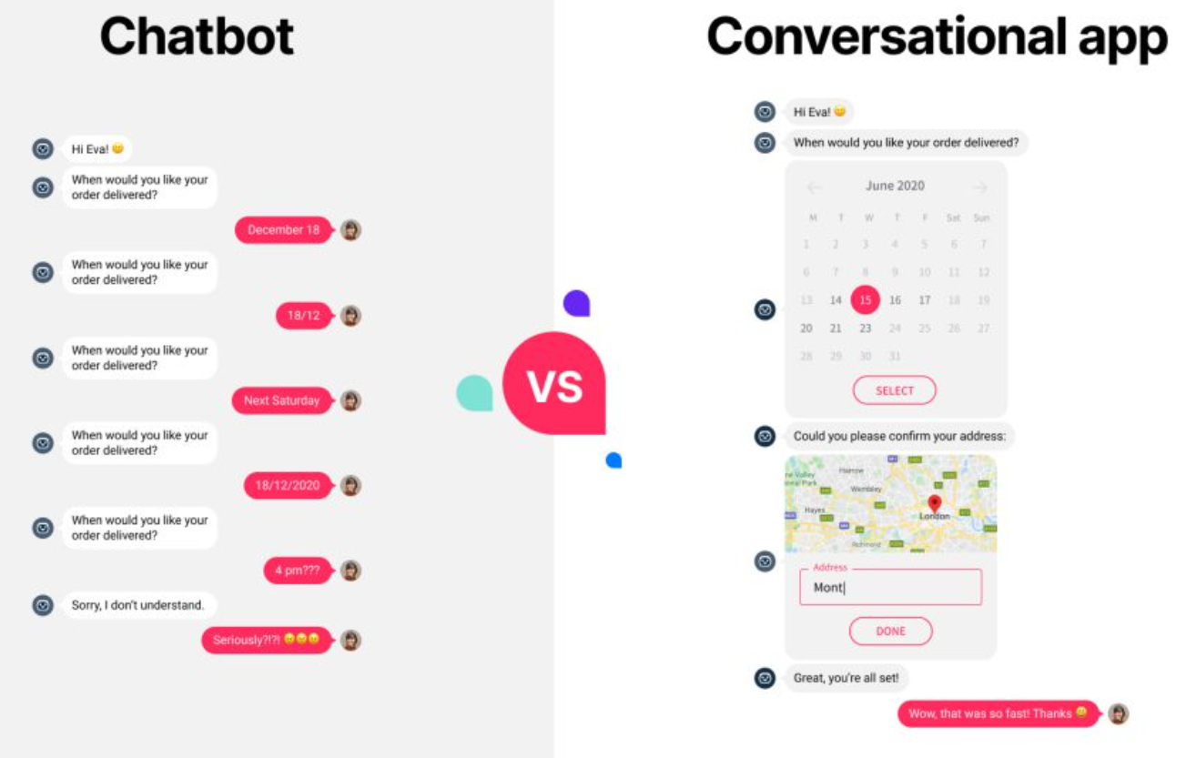*Comparing traditional chatbots (left) to conversational chatbots (right)*

**2. Fintech chatbots simplify complex topics and workflows**

Fintech chatbots are not seen as a cost-cutting technique or a tool to replace human agents by successful fintech organizations. While fintech chatbots can help with KPIs like cost-per-contact, this isn't the main goal. In fact, chatbots are seen as a tool by successful fintechs to boost client happiness and loyalty. They meticulously plan the customer experience and only employ automation where it improves customer pleasure.

For any particular use case, a chatbot must meet or surpass the experience that the human support team can provide. For fintechs, the decision to use a chatbot involves a careful assessment of the customer journey. They identify potential causes of conflict and assess present resources.

Fintechs are successfully automating processes that, until now, were too complex to be handled by a bot. They are designing experiences that eliminate paperwork, hold times, and friction in their customer service models.

# Possible Challenges for Chatbots in Fintech

While chatbots are increasingly becoming popular in Fintech, especially among Financial Institutions, they may still face its own challenges and limitations because after all, it is very difficult for Artificial Intelligence to completely replace humans in performing tasks that were originally done by individuals behind their desks.

## Quality of Conversation

As iterated before, chatbots' primary purpose is to simulate human response to automate conversations with users or customers. Hence when financial institutions deploy chatbots, the main objective is to direct simple requests from users to be handled automatically 24/7 from a live chatbot. Simple requests include checking of bank account balance or status of a fund transfer.

However, chatbots are mostly driven by NLP algorithms and will provide a response based on the machine’s interpretation of the user’s input. This works well under most circumstances, with the complexity of such requests being low. If a person types or speaks in a unique manner that is not recognised by the machine, it will not be able to provide assistance to this group of users. On the other hand, requests handled by live chat technology (where an employee is behind the screen) are often handled much better. Further clarifications can be made much easier without users having the need to undergo an “endless cycle of frustration” where there is no avenue for a human to help clarify and rectify the problem.

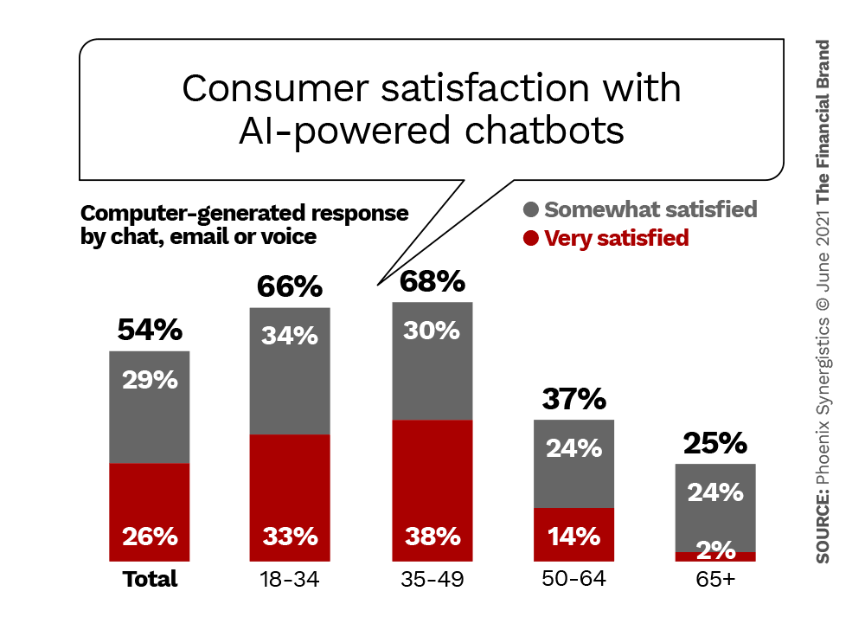

*Study by Phoenix Synergistics on Consumer Satisfaction with Chatbots*

From the study above, we can see that among the population, half of the respondents are not satisfied with their experience when interacting with a chatbot. This sentiment is much more prevalent among the older users. A possible reason is because younger users are able to provide short and succinct inputs for the chatbots, containing keywords which the AI algorithm is able to pick up well. Another likely reason to explain this result is because the younger generation are generally more tech-savvy while the older users prefer the old-school method of calling.

Regardless, this shows that chatbots do indeed have room for improvement with respect to the AI capabilities to simulate responses to be as human-like as possible. This is so that users are able to feel like they are communicating with another human being behind the screen. Moreover, chatbots need to be more robust to different types of queries so that it can understand and provide users with the necessary information needed.

## The Need for Both Human and Bots

While chatbots are able to provide assistance for Financial Institutions, it should never be stand-alone. Any input that is not recognised by the machine will result in erroneous response and ultimately, poor user experience. Hence, in order to ensure the successful use of chatbots, humans must always be in the picture. This is so that when all else fails, users can still be directed and communicate with another human who has a better understanding than a machine.

# Conclusion

Chatbots are a great example of businesses integrating technology into one of their many business solutions. The technology behind chatbots is nowhere near perfect such that it can completely replace human response, but it is fairly good at it. Hence, until then, we cannot be completely reliant on technology and still need human intervention.

# References

## Types of Chatbots

1. <https://www.expert.ai/blog/chatbot/>
2. <https://botscrew.com/blog/what-are-bots/>
3. <https://medium.com/predict/rule-based-vs-ai-based-chatbots-28613db3fe2c>

## What are Fintech Chatbots?

1. <https://getstream.io/blog/fintech-chatbots-conversational-banking/>
2. <https://www.hubtype.com/blog/fintech-chatbots>
3. <https://juristech.net/juristech/the-rise-of-chatbots-in-the-fintech-industry/>
4. <https://thefintechtimes.com/ai-chatbots-closing-the-gap-between-fintech-and-traditional-banking/>

## Possible Challengers for Chatbots in Fintech

1. <https://thefinancialbrand.com/123062/why-chatbots-fail-in-banking-conversational-ai-virtual-assistants/>